Day 36

Prep lab 3.1.1 pg 152 – full write up

Proportioning Techniques

Please tell me about the graph…

y
y = mx + b

y varies directly with x
relationship = slope

y has an initial value

x

Please tell me about the graph…
y
not as much info

x

If only we could turn curves into straight lines we could get more information out of them…Calculus – take the derivative – works if you know the equation and calculus.

x | y | 1/x
1 | 1 | 1
2 | 0.5 | 0.5
3 | 0.3333 | 0.3333
4 | 0.25 | 0.25
5 | 0.2 | 0.2
6 | 0.1667 | 0.1667
Graphical manipulation…
y y

I recognize that as a 1/x graph
so if I change my x to 1/x

x 1/x equation of line - ???? → y = m(1/x) + b

Others

x²

x²
√ x

√x

F F F

d 1/d 1/d²
gravity is a (1/d²) force
Day 37

Lab 3.1.1 pg 152 – Centripetal Acceleration
Day 38
Circular motion derivation – overhead note

R+MN 3.1 P#2,4,5,6,8,9
Q#5,6
3.2 P#2-8
Circular Motion of a Particle

Consider a particle moving in a circular orbit with constant speed. Since the direction continuously changes, the particle is accelerating:
A
C
B
ΔS
v₁
v₂
Δθ

During time Δt, the particle moves from A to B through an angle Δθ along an arc of length ΔS.

Δv = v₂ – v₁ or v₂ = v₁ + Δv
v₁
Δv
v₂

This triangle is similar to ABC.

Therefore, 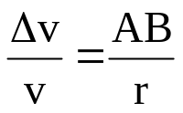 but, AB → ΔS as Δt → 0

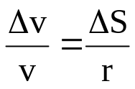 or, 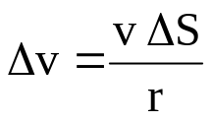

Remember: 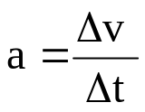 Now, 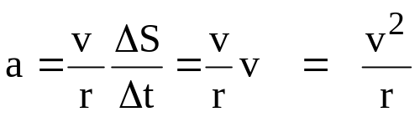

Centripetal and Centrifugal Force

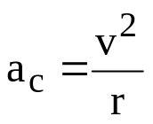

Centripetal acceleration
Newton’s 2nd Law: 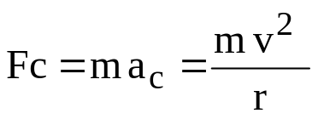

Centripetal Force is the force necessary to cause an object to move from a linear path (straight line) into a circular path.

Eg. An ant (m = 0.10 g) is crawling on a turntable at a radius of 10 cm. If the linear speed of the ant is 20 cm/s, what is the centripetal force?

Wait….. this is like the force we experience in a car going around a curve. The force we experience is directed outward. This is classic Newton’s 3rd Law.

Reaction force to centripetal force is called Centrifugal Force and is directed outwards.
F_{centrifugal} = F _{centripetal}

Applications of centrifugal forces:
1. centrifuge
2. roller coaster – centrifugal force keeps roller coaster on tracks.

3. NASA trainer / amusement ride

Eg. A passenger in a jet (m = 75 kg) notices that the plane is banking in a circular path. If the centrifugal force on the person is 200 N, and the plane’s speed is 1000 km/h, find the radius of the turn.

Problems with Circular Motion

- Roller Coaster. Find the minimum velocity for this coaster to stay on the track.
Mass = 1000kg, radius = 20m.

- An object is rotated in a vertical circle with r = 1.2m and a freq = 1.5 Hz. Find tension (T) in string at top (min T) and bottom (max T). Mass = 0.250 kg.

- A car travels along an unbanked curve.
r = 100m m = 2000kg μ_{s} = 0.8
Find max speed allowed without sliding sideways.

- Same car on same curve etc. only this time the curve is banked at 14º.
Find v_{max}. Why are curves banked?

Day 39, Day 40, Day 41

Day 39 - Work period for Circular Motion
R+MN 3.1 P# 2,4,5,6,8,9
Q# 5,6
3.2 P# 2-8

Day 40
R+MN 3.3 P# 3,4,5,9,11,12
Q# 2,5,6

Day 41
R+MN 3.4 P#1,4,7,8,10
Q#4,6

Orbit – the path an object takes around another. Why would this happen? Wouldn’t gravity pull it down?
The object must have a velocity perpendicular to gravity that curves its fall. This velocity is “in balance” with gravity.

Demo throwing chalk at greater velocities – curvature decreases – if fast enough that curvature would match earth’s curvature and it would never hit ground!

At what speed does this curvature match? When will balance happen?
m_{s} = mass of satellite
m_{e} = mass of earth

F_{gravity} = F_{centrifugal}

Universal gravitation = ma_{c} (centripetal = centrifugal)

Gm_{s}m_{e} = m_{s}v²nnn
r² rnnnn

v = Gm_{e}
r

Apparent weight – the weight you feel (weight changes, mass does not)
- stand on a scale
- stand on a scale while free falling after jumping out of a plane
- stand on a scale while in orbit on the ISS – weightless – but still 80% of gravity!
- stand on a scale in an elevator accelerating up
- stand on a scale in an elevator accelerating down
- stand on a scale in an elevator moving up at a constant velocity
- stand on the wall of a space station that is rotating
Day 42

Chapter 3 self quiz
Review # 2,4,6,8,12,13,15,26

Quiz tomorrow
Day 43
Take up HW

Chapter 3 quiz
R+MN 6.1 P#1-8

Gravitational Fields

Do force fields exist? Star Trek?

If I hold this ____ at this height, is there gravity there? Is the gravity still there if the object isn’t. Gravity exists as a field – it is a force waiting to happen.

What determines the force of gravity acting between any two objects? – mass of each and distance between
F_{G} = GMm
r²
G = 6.67*10⁻¹¹ Nm² (check units)
kg²
M = larger mass (kg)
m = smaller mass (kg)
r = distance between centres of mass (m)

But F_{g} = mg (on earth)
So… F_{g} = F_{G}

mg = GMm
r²

g = GM
r²

What happens to the size of “g” as altitude increases? “g” decreases

Field lines get less ‘dense’ as you move away from centre of mass of object.

Do Sample problems 1,2 pg 275,276
Day 44

Take up HW

Kepler video

Day 45
Kepler’s laws overhead

Forward to Newton

Centripetal force F = mv²
r

but for planets we use universal gravitation to find F

GM_{sun}m_{planet} = m_{planet}v²
r² r
solve for v
v = GM_{sun}
r

but T = 2Πr since time = d
v v

T = 2Πr

GM_{sun}
r

T² = 4Π²r²
GM_{sun}
r

T² = 4Π²r² * r
GM_{sun}

T² = 4Π²r³
GM_{sun}
Rearrange r³ = GM_{sun}
T² 4Π²

K = r³ = GM_{sun}
T² 4Π²
Find the mass of the sun! sun earth radii = 1.495*10¹¹m
Do sample problem 1 pg 278
2 pg 281

R+MN 6.2 P # 1-4, 10-12
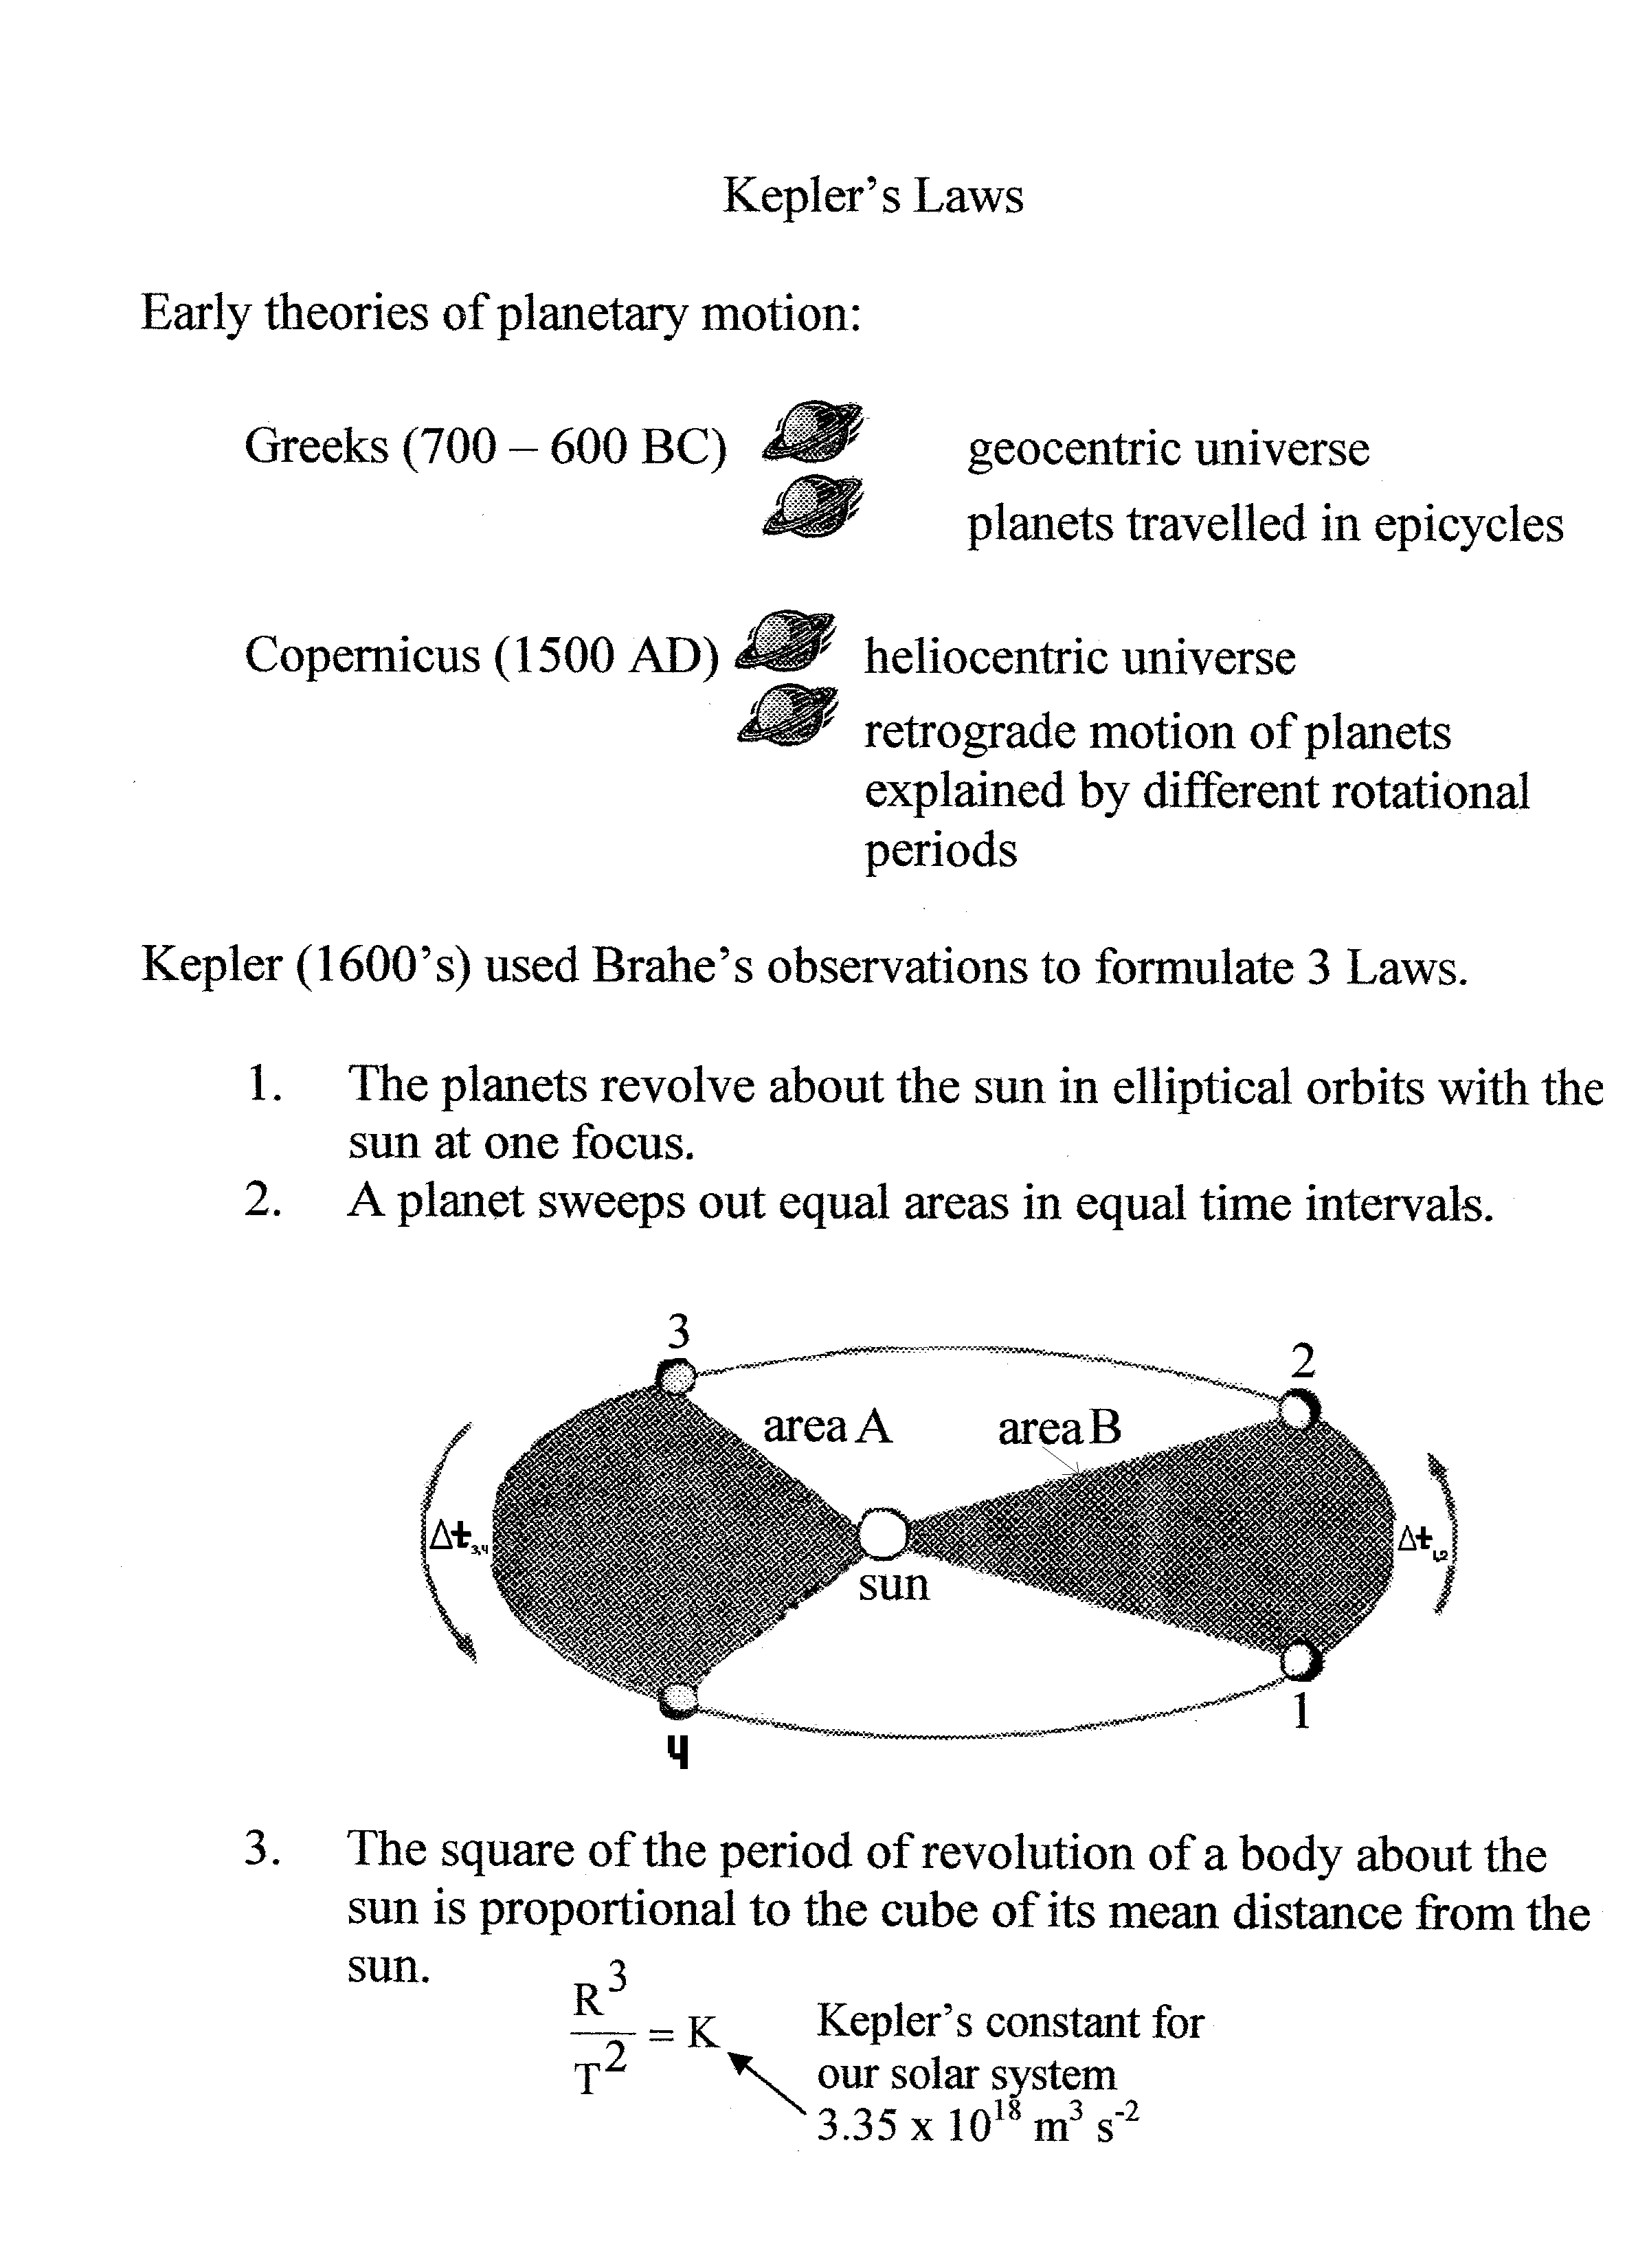

Day 46

R+MN 6.3 P# 1-4,8,9,10

Overhead notes - Gravitational Potential Energy

Gravitational Potential Energy

Near earth’s surface, “g” is constant but at larger distances “g” decreases so F=mg no longer applies.

Universal Gravitation F_{G} = GMm
r²
Earth
r₁ Has E_{g} increased or decreased?

r₂

E_{g} has increased! But E_{g} when r=∞ is 0 (because F=0)

How can we INCREASE to ZERO?

We must be negative on earth’s Surface!!

What does a graph of - F_{g} vs r - look like?
r = separation between objects’ centres of mass

F
F₁

F₂
r₁ r₂ r

What does the area under an F vs d graph represent?

Hint – think springs → work done to move object OR change in potential energy.

In this case the area under the graph is the change in Gravitational Potential energy.

How do we find the area under a curve?

!! CALCULUS !!

Derivative = slope of a line at any point
opposites
Integral = area under curve

Remember…
d _{slope} v _{slope} a

_{area} _{area}

t t t

F
F₁

F₂
r₁ r₂ r

_{r2}
∫^{GMm δr}
^{r1}
∆E_{g} =
r²

∆E_{g} = GMm
_{r2}
∫ ^{1 δr}
^{r1}
r²

∆E_{g} = GMm - 1 r₂
r r₁

∆E_{g} = GMm - 1 - - 1
r₂ r₁
∆E_{g} = -GMm - -GMm
r₂ r₁

∆E_{g} = E_{g} _{at position 2} - E_{g} _{at position 1}

but if r₂= ∞, E_{g} _{at position 2} = 0

So…

The gravitational energy at any position…

Where “r” is the separation between the two objects’ centres of mass.
E_{g} = -GMm
r

What will a graph of E_{g} vs separation (r) look like?

r₁ r₂ r

-GMm
r₂

-GMm
r₁

E_{g}
A

Note: E_{g} is always negative but as “r” increases, E_{g} approaches 0 (Eg is increasing! because it is a smaller negative).

The 0 value occurs at infinite separation.

What is ∆E_{g} of a 100kg object lifted from the surface of earth to an altitude of 400km?
[r_{E}=6.4*10⁶m, M_{E}=5.98*10²⁴kg]

Escape Velocity – in order to escape the object must get infinitely far from earth.

∆E_{g} = -GMm - -GMm
r₂ r₁

∆E_{g} = -GMm - -GMm
∞ r_{E}

∆E_{g} = - -GMm -- → +
r_{E}
This Eg must be created by the velocity so…

E_{k} = E_{g}

m cancels
½ mv² = GM_{E}m
r_{E}
Try it!
v = 2GM_{E}
r_{E}

v = 11.2 km/s
Orbits – movement in a path around another object.
Why does the moon not hit earth?
Throw chalk at different speeds.
Draw a cannon on the earth
The curvature of the path matches the curvature of the primary object.

The rate of fall is BALANCED by the horizontal motion. What is balanced?

E_{T} = E_{K} + E_{g}
E_{T} = ½ mv² + -GM_{E}m
1
r_{orbit}

But a circular orbit has a centripetal force that IS gravity.

F_{c} = F_{g}
r orbit cancels
mv² = GM_{E}m
r_{orbit} r²_{orbit}
Multiply by ½
mv² = GM_{E}m
r_{orbit}

½ mv² = 1 GM_{E}m sub
2
2
1
2 r_{orbit}

E_{T} = 1 GM_{E}m + -GM_{E}m 2 r_{orbit} r_{orbit}

E_{T} = - 1 GM_{E}m
2 r_{orbit}

E_{T} = ½ E_{g}

E_{T} = E_{k} + E_{g}

½ E_{g} = E_{k} + E_{g}
then

E_{k} = - ½ E_{g}

Day 47 and 48

Day 47

All Q’s in chapter 6
Chapter 6 self quiz
Chapter 6 Review – 3,4,6,7,10,12,14,16,22

SHM pg 212 to 218 P#16-21, 23-26

Day 48

Test Unit 3 – Ch 3,6, SHM

